Supplemental Payroll Request Instructions
Revised 7/31/2026

There are two important changes coming up for supplemental pay for 2026-27 school year, please note these below.
- Beginning 7/1/2026, the NPERS contribution rate dropped to 7.25% for employee contributions. The employer will contribute 101% of that rate or 7.3225%.
- Beginning on August 1, 2026, the rates for supplemental pay for contractual employees will change:
Direct Teaching | $37
Non Direct teaching | $30
Supervision | $30
Curriculum writing (must be approved) | $41
These rates apply to work done on or after August 1, 2026.
We have revised versions of the supplemental pay forms for these two changes and they will be attached to this information.
Please note, we will not accept supplemental pay forms that are handwritten or have missing information such as dates of service, type of service, budget code. We scan all payroll documents with Optical Character Recognition (OCR), with makes handwritten items unsearchable.
We appreciate your help to make sure these forms are completed properly.

How To Submit Supplemental Pay Forms
- Forms can be submitted via either a paper form dropped off in Payroll or sent in school mail or a scanned copy sent via email. Please DO NOT email the form and then send the paper copy too.
- Employee numbers must match employee names. It is the responsibility of the administrator submitting the form to make sure these numbers are correct. If the wrong number is submitted, the wrong person will be paid. (A)
- Forms must be signed by the building administrator or person authorized for the budget code and also must indicate who completed the form. (B)
- The budget code, account code and account description must be verified and correct for the form to be paid. (C)
- The dates the work was completed and the type of service must be filled in on the form. This is especially important as NPERS will often ask about this information and this can affect NPERS benefits. (D)
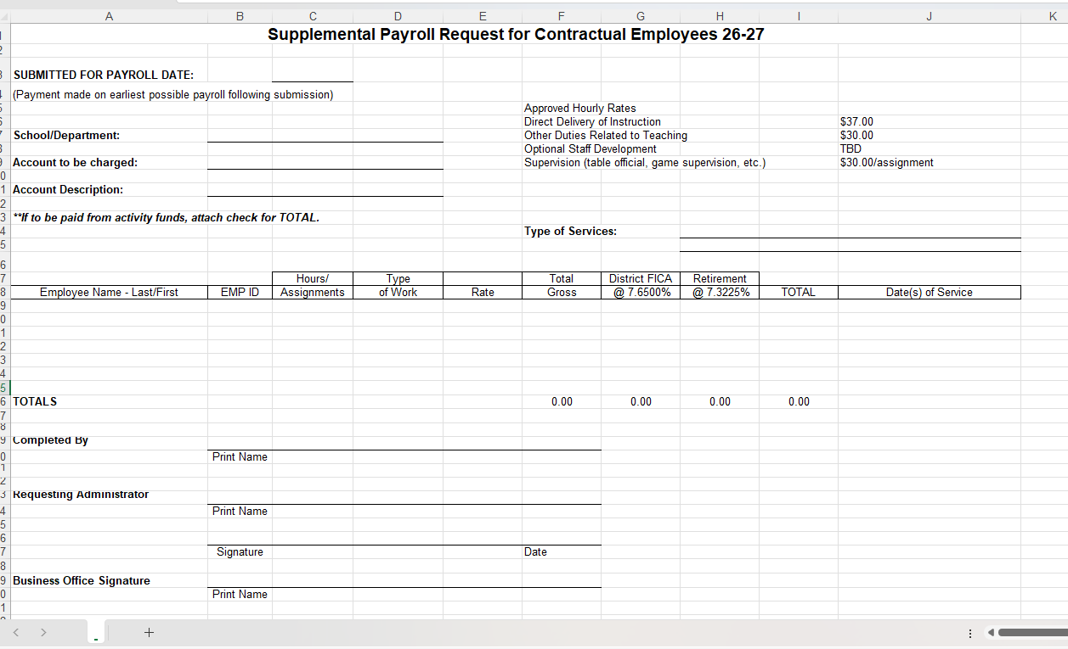
B
D
C
A

Budget Codes

The budget code for supplemental pay forms must be entered in the following format:
XX | XXXX | XXXX | XXX | XXX | XXXXX
Fund | Program | Sub Program | Location | Responsibility | Account

Before using a budget code on a supplemental pay form, be sure to verify that it is a valid budget code in eFinance.

The Account Code can only be chosen from one of the following numbers:
Account Code | Use for this type of work:
01100 (TEACH SALARY) | Homebound and Summer School teaching only.
01120 (EXTENDED CONTRACTS) | Outside contract hours for secondary in-school supervision (e.g., Saturday school.)
01210 (SUB-EXEMPT/SALARIED) | Substitutes for teachers and other salaried staff only. Supplemental pays to this account code are rare.
01250 (TEMPORARY HELP) | Supervision and workers for extracurricular activities (e.g., athletics, tournaments, camps, etc.)
01280 (TEACHING/WRITING/INSERVIC) | Teacher hours that do not correspond to any of the account descriptions above.
01500 (INSTRUCTIONAL AIDES) | For para hours not tracked in the Time Clock (rare).

You may not use other account codes for supplemental pay forms. The only account codes which can be entered in the payroll system for salary expenditures are those beginning with “01” (e.g., 01280). Please contact Chris Hughes with budget and/or account code questions related to Payroll (cmhughes@mpsomaha.org or 715-8201).

Cutoff/deadline:
- The cutoff deadline for monthly supplemental pay forms is the 25th of the prior month.
- The cutoff deadline for hourly supplemental pay forms is the day timecards need to be approved.
- Payroll is processed several days prior to the pay date. Any late submissions will be paid on the next payroll unless approved by the Accounting Manager.

Contractual versus Hourly Definition:
- Contractual employees (also known as monthly or salaried employees) are paid on the “Contractual” form. This includes teachers, counselors, social workers, and psychologists.
- Hourly employees are paid on the “Hourly” form. This includes sub teachers and all employees who punch the time clock such as paraprofessionals, building secretaries, custodians, and food service employees.
- These different types of employees must be paid on separate supplemental pay forms as they are paid on two different payrolls. If there are any questions about an employee’s status as contractual or hourly, please contact Payroll.

Rates:
- For contractual employees, the rate paid must be:
  - $30 per hour - Duties related to teaching but not involving direct delivery of instruction which are performed in addition to a teacher’s normal classroom responsibilities (e.g., curriculum writing, required staff development, assessment development).
  - $37 per hour - Teaching duties involving direct delivery of instruction which are performed in addition to a teacher’s normal classroom responsibilities (e.g., after school study center, summer school, advancement placement review, etc.)
  - $30 per assignment – Supervision duties.
  - Other rates must be approved by Human Resources before submitting to Payroll.
- For hourly employees, the rate paid must be:
  - Employee’s hourly rate (IHR) or $30 for supervision assignments.

PLEASE NOTE:
- Incomplete forms will be returned to the building/department for correction. These are examples of problems with supplemental pay forms received this summer:
  - Missing or incorrect employee numbers
  - Handwritten employee numbers
  - Employee numbers do not match the employee names
  - Type of services not indicated
  - Dates of service not indicated
  - Hourly and monthly employees on the same form

